Name: …………………………………………………….. Adm No. ………………
Class. …………............ Date…………………….

232/3
PHYSICS
PRACTICAL
PAPER 3
MARCH 2019
TIME: 2 HOURS, 30 MIN

INSTRUCTIONS TO THE CANDIDATES:
- Write your name, admission number and class in the spaces provided above.
- Answer all questions in the spaces provided in the question paper.
- You are supposed to spend the first 15 minutes of the 2 hours, 30min allowed for this paper reading the whole paper carefully.
- Marks are given for a clear record of the observation actually made, their suitability, accuracy and the use made of them.
- Candidates are advised to record their observations as soon as they are made.
- Mathematical tables, slide rules and calculators may be used.
- Record your observations as soon as you make them.
For Examiners’ Use Only
CANDIDATE’S
SCORE
MAXIMUM  SCORE | 40
This paper consists of 6 printed pages. Candidates should check to ascertain that all pages are printed as indicated and that no questions are missing.

- You are provided with the following:
- Two retort stands, two clamps, two bosses
- A stop-watch
- A metre rule
- Some thread
- Some cellotape
- Two 50g masses
Proceed as follows:
- Using the two retort stands set up two simple pendulums each of length 80cm and 46cm apart such that their points of support are in the same horizontal plane.

Ensure that the retort stands are firmly held on the bench. Using the sellotape provided, attach a half-metre rule horizontally on to the strings of pendulums, such that its upper edge is at a distance D = 20cm below the points of suspension. Ensure that the pendulums hang freely without touching the bench.
q
Figure 29 one shows the set up.

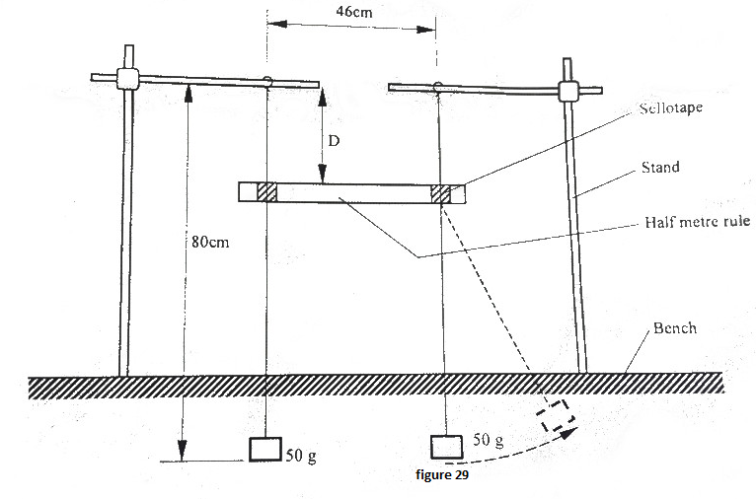

- While holding one of the 50g mass of one pendulum, displace the other 50g mass to one side, (see the dotted position in figure 1) and then release both pendulums simultaneously.

- Observe the motion of the two masses for about 30 seconds and hence:

- Describe the pattern of the oscillation of the two masses; (1mark)
…………………………………………………………………………………………………………………………………………………………….
…………………………………………………………………………………………………………………………………………………………….

- State a reason for this pattern in terms of mechanical energy (1mark)
…………………………………………………………………………………………………………………………………………………………….
…………………………………………………………………………………………………………………………………………………………….

- Now focus on any one of the two pendulums.
Measure and record in table 1 the time T taken for the motion to change from one zero-amplitude state to the next zero-amplitude state.
(Zero-amplitude is when the pendulum is momentarily at rest.)

- Repeat the procedure in (d) for other values of D shown in table 1. (Hint: D can be varied by sliding the half-metre rule downwards along the strings of the pendulums without removing the sellotape.) Complete the table.
Do not dismantle the apparatus yet.

Table 1
D (cm) | 20 | 25 | 30 | 35 | 40 | 45 | 50
T (s)

f = $\frac{1}{T}$ (s⁻¹)

(8mks)
- Plot a graph of f (y axis) against D (5marks)

- Use the graph to determine the frequency f_{b}, the value of f when D = 38 cm.

f_{b} =……………………………………………………… (1mark)

- Now set the distance D at 38 cm, and repeat the procedure in (b) above.

Measure the time interval t between two successive zero-amplitudes for one pendulum and count the number n of the oscillations in the interval.
n = ……………………………………………………….. (1mark)

t = ………………………………………………………… (1mark)

- Determine f₀ given that, f₀ =$\frac{n}{t}$ (1mark)
……………………………………………………………………………………………………………………………………………………………
……………………………………………………………………………………………………………………………………………………………
…………………………………………………………………………………………………………………………………………………………….
- Determine f₁ given that f_{b} = f₁ – f₀ (1mark)

- You are provided with the following
- 2 dry cells
- A cell holder
- A nichrome wire mounted on a metre rule
- An ammeter A
- A voltmeter V
- A jockey J
- A switch S
- 8 connecting wires
- Proceed as follows
- Set the apparatus as shown in figure 1

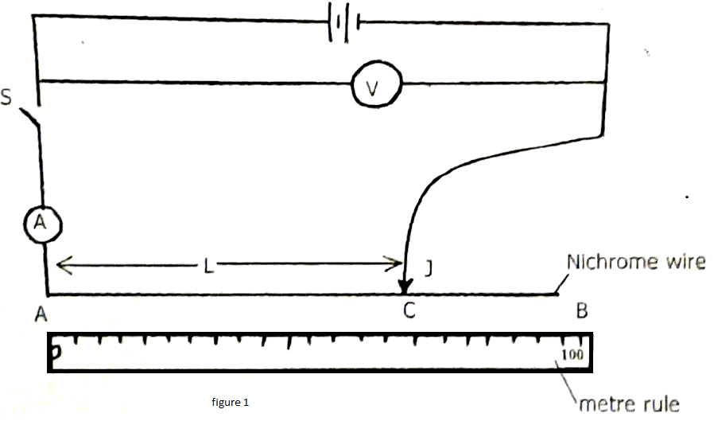

- With the switch open, record the reading E of the voltmeter
E....................................................................................... (1 mark)
(c) Place the jockey, on the nichrome wire at 100 cm mark. Close the switch read and records the values of I (ammeter reading) and the corresponding values of V (voltmeter reading) in table

(d) Repeat (c) above for length L= 70 cm, 60cm, 50cm, 40cm and 20cm.complete the Table (7mrks)
L(cm) | 100 | 70 | 60 | 50 | 40 | 20
I(A)
V(v)
E-V (v)

(e) Plot a graph of (E-V) (y-axis) against I (5 marks)

(f) Determine the slope of the graph (3 marks)

(g) Given that E = V + Ir, from the graph determine
(i) The internal resistance, r, of the battery (2 marks)

(ii) V when I is 0.3A (2 marks)

